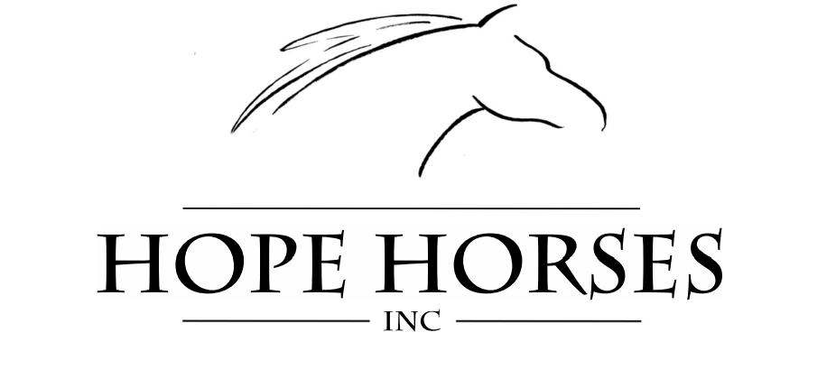
VOLUNTEER HANDBOOK

1301 CONVENT ROAD NE
CULLMAN, AL 35058

PHONE: 256-841-6290 or 256-566-2088
EMAIL: VOLUNTEER@HOPEHORSESINC.COM
WEBSITE: WWW.HOPEHORSESINC.COM

Welcome!

Dear Volunteer,

On behalf of the Hope Horses, Inc. Board of Directors and Staff, I would like to give you a warm welcome and a big thank you for showing interest into volunteering at Hope Horses, Inc. We are excited to get to know you and serve beside you. Please know that we always want you to feel valued and like you belong here, and we sincerely hope that you get as much out of this experience as you put in. We want you to know that because of your time and dedication to our program we are able to serve more individuals in our community. There are many opportunities for you here at the Hope Horses, Inc. facility! You are joining a great team of volunteers! If you have any questions or concerns please let us know!

Sincerely,
Allison Curl
Volunteer Coordinator
Hope Horses, Inc.

About Us

Our Mission Statement: The mission of Hope Horses, Inc. is to provide therapeutic horsemanship opportunities to children and adults with physical, social, cognitive, and emotional needs.

History: The Hope Horses program was a vision and dream of David Poynor's in 2007. With several years of research, a board of directors was organized and incorporated in 2010. Hope Horses was approved as a 501(c) 3 non-profit organization in 2011. The Benedictine Sisters of Cullman opened the gates to a permanent home for Hope Horses in 2011. Fundraising and site preparations began for a new barn in 2012. The community has much ownership in the program by the way of donating materials and labor for the barn. In October 2013, Jon and Dr. Glori Short opened their barn, arena, and pasture for Hope Horses to evaluate horses while the barn was under construction on 1301 Convent Road. Four horses were evaluated and accepted as program horses. June 2014, Hope Horses began offering equine therapeutic activities at the Short Farm. In 2015, Hope Horses began offering equine therapeutic activities on 1301 Convent Road.

Facility: Hope Horses, Inc. is located on Convent Road. The barn is built with 9 stalls, a covered arena, and outdoor arena for the safety of lessons.

Safety: It is our top priority to provide a safe environment at Hope for all of those involved in the program. Working with horses is a risk activity and policies have been developed to minimize the risk. Not only is safety a priority for the staff but also for our volunteers.

VOLUNTEER CODE OF ETHICS

Hope Horses, Inc. seeks to provide a therapeutic, professional, beautiful, safe, and peaceful environment for students, visitors, staff members, volunteers, and horses. The purpose of this code of ethics is to provide volunteers with an ethical and responsible framework from which to serve. YOU REPRESENT HOPE!

As a volunteer, I will:

- Listen carefully to the Hope Horses, Inc. staff members and recognize that they follow certain procedures for a reason.
- Respect my fellow volunteers.
- Strive to keep the Executive Director and Staff informed of opportunities in the community for promoting Hope Horses, Inc. and potential funding opportunities.
- Keep well informed of developments and policies relevant to my volunteer responsibilities and the Hope Horses, Inc. policies. I understand that the preferred communication is through the Volunteer Coordinator.
- Participate actively in volunteer trainings and assist other volunteers as they join Hope Horses, Inc.
- Bring to the attention of the Executive Director any issues that I believe will have an adverse effect on the organization or those we serve.
- Help curtail any negative conversations, rumors, or gossip.
- Refrain from bringing in my personal interests or financially benefiting as a result of my relationship to Hope Horses, Inc.
- Consider myself having a vested interest in the organization and do my best to ensure that it is well maintained – keeping quality and safety in mind.
- Always strive to learn how to be a more effective volunteer while also assisting the staff in improving the volunteer program.
- Notify staff if I cannot physically do something that is asked of me.

As a volunteer, I will not:

- Use the organization for my personal advantage or that of my friends or relatives.
- Discuss confidential issues with anyone not involved with those issues.
- Interfere with the duties of staff members or undermine their authority.
- Criticize fellow volunteers and staff members or their opinions.
- Mistreat horses or any other animals on the Hope Horses, Inc. property in any fashion.
- Take pictures of the Hope Horses, Inc. students or participants.

Where repeated attempts have been made to rectify a volunteer’s non-compliance with the Code of Ethics, or where a severe violation of the Code of Ethics has occurred, prompt action will be taken to remove or suspend the individual.

As a Hope Horses, Inc. volunteer, I agree to adhere to and to be responsible for maintaining the above Code of Ethics.

________________________________________________________________
Signature of Volunteer, or parent/guardian if under 18 DATE

Barn Rules

- No smoking anywhere on the premises
- Please drive slowly; we love our children, horses, and visitors.
- Closed-toe shoes are required at all times.
- Direct access to any horse must be supervised by one of our instructors.
- No running, “horse-play”, or roughhousing in the barn.
- No hand feeding the horses.
- Parents must supervise all students who are not in lessons.
- Observe all “off limits” signs.
- Be respectful of the participants and visitors.
- Have Fun!

Volunteer Program

All Hope Horses, Inc. volunteers must be 14 years or older to volunteer. Volunteers under 14 years must be present with an adult. There are many different areas to volunteer. There is always something to do – those with horse experience and those without, those who wish to volunteer weekly or those who wish to volunteer occasionally. All volunteers 19 or older must complete a background check. Background check instructions are located in this packet. When becoming a Hope volunteers, every individual is required to go through the following levels. There will be no skipping of levels. You must go through the proper training and be signed off by a Hope Staff member before proceeding to the next training level. Every effort will be made to place volunteers in the program of their choice. The Hope Horses, Inc. Staff and Board of Directors has the right to discontinue the service of any volunteer who fails to follow given code of ethics or breaches confidentiality. Attending volunteer orientation and trainings is required for all who wish to volunteer at Hope Horses, Inc.

Volunteer Positions Descriptions

All volunteers must start training in the following levels:
- Level 1: Barn volunteer
- Level 2: Side walker
- Level 3: Horse Handler

Level 1 barn volunteer. A barn volunteer consists of completing all barn chores, keeping the stalls clean and arena clean (includes water buckets and feed buckets), assist activities director and instructors in arena set up. The barn volunteer has an extremely important job. Not only are you helping with easy transition from one lesson to the next, every day people are coming to the barn. Each person that enters can either be a future participant, volunteer, Board Member, or most importantly a donor. As a barn volunteer, you will fulfill a mission of keeping the barn in tiptop shape and provide an incredible first impression of our facility to new visitors.

Level 2 Side walkers. As a side walker, you will be expected to participate in lessons. Your main responsibility is to listen to the instructor and communicate to the instructor for the participant. Your instructor will guide you and give you the information you need before each lesson so that you will be able to do your job to the best of your ability. The instructor will tell you how much assisting is needed.

Level 3 Horse Handlers. Your job as a horse handler is to focus only on the horse. You may also assist in bring in horses and turning horses out only if you are assigned.

Each day that you come into the barn, check with the instructor, or volunteer coordinator to find your assigned position. If you are scheduled to help in a lesson, your name will be on the lesson board in either the horse handler or side walker column. If you are on a specific level and would like to get to a new level, please contact volunteer@hopehorsesinc.com to schedule training days.

The following requirements attain to all levels of volunteering:
- Must attend volunteer training and orientation session
- Be physically able to walk and/or jog
- Be able to work without supervision
- Be able to lift your arm shoulder height for up to 45 minutes
- Possess a positive attitude and willingness to work
- Be respectful of participants and others around you
- Always be aware of safety issues and following the instructor’s directions
- Be respectful of a participant’s tolerance to touching. Hugs and other displays of affection should be left for the participant to initiate.
- Most importantly, come with a heart to serve.

Frequently Asked Questions

When can I start volunteering?
Once you have completed your volunteer application, completed a background check (if you are 19 years or older), and completed orientation, you will be scheduled for a day and time to start volunteering.

What do I do when I arrive at Hope Horses, Inc. for the first time?
When you arrive at the barn, you will enter through the staff/volunteer door and go into the tack room. Leave your phone, purse, or any other personal belongings in a cubby. Then check the lesson board and start volunteering

Why do I have to log my hours?
When you come to volunteer, please sign out. Signing out is very important, as tracking volunteer hours will help us to secure funding and show potential donors the tremendous community support we have! Please use the iPad to log your hours!

How can I see how many hours I served this term or year?
A total number of volunteer hours can be collected from the Volunteer Coordinator, Allison Curl.

Can I become friends with the students/ or their parents?
If you are a tenderhearted person, you are likely to feel quite connected to participants. You are also likely to feel a special connection with a specific participant. Please refrain from giving money or gifts to the students, do not offer rides or other personal favors, and avoid giving out personal contact information. You are cautioned to consider the consequences before connecting with students on any social media site. Be a support person in their lives while they are at the barn, and know that you are making an eternal difference even if you are only with them for a short time.

Why is the student I am working with progressing so slowly?
The session’s pace is a bit slower than traditional barns; so do not expect to be preparing beginner riders for showing.
Will I be notified if a student cancels their lesson?
The volunteer coordinator will contact you upon hearing a student has cancelled. If the student you are scheduled to assist cancels or does not show up, please ask a staff person if there is anything else that you can do. There are other tasks to be done!

What is the weather policy?
The weather also affects the lesson schedule at the barn. Please do not assume that lessons are cancelled due to rain. We will use the opportunity to do ground work with the students. If it is thundering and lightning, lesson will be ground lessons. Generally, we determine whether lessons will take place two hours before the lesson time. If you feel like traveling from where you are to Hope Horses, Inc. is dangerous, please text the Volunteer Coordinator. Every effort will be made to notify volunteers of cancellations in advance. See HEAT POLICY

Will someone inform me of the student’s reasons for participating in the Hope Horses, Inc. program?
Many of our participants have physical, cognitive, or emotional disabilities. They want to be spoken to with respect. They don’t want to be questioned or made to feel uncomfortable, they want to learn and have a good time, and they want to spend time with horses! Do not expect to be told the participant’s circumstances for being at Hope Horses, Inc. Please do not ask prodding or inappropriate questions, and please let a staff member know if you are uncomfortable working with children with a specific ability.

Can I take pictures of my student or the horses?
Volunteers are encouraged to share your experience at Hope Horses, Inc. Feel free to share the Hope Horses, Inc. Facebook and Instagram post. However, it is very important that Hope Horses, Inc. provides a safe place for our students and their families. Please do not take pictures of our students or their families. If you see a great photo opportunity, send to volunteer@hopehorsesinc.com.

What is the dress code for volunteers?
Volunteers should not wear open-toed shoes, crocs, or sandals when working at the barn. We recommend that our volunteers wear supportive shoes and boots for protection. See Dress Code Policy.

Hope Horses, Inc. Policy’s

Attendance
ASKED TO BE AT THE BARN 1 DAY FOR 6 WEEKS. It is very important to attend your assigned class time. To ensure the safety of the participants, a pre-determined number of volunteers are needed for each class and each volunteer is counted on to be there during that time in order for the class to be carried out. If you are unable to attend or are running late for your lesson, please call ALLISON (256) 566-2088 OR EMAIL VOLUNTEER@HOPEHORSESINC.COM as soon as possible.

Remember communication is key.

Please plan to arrive 30 minutes before your schedule lesson time. If you arrive early and a class is underway, please assist with the barn chore list.

Dress Code Policy
Volunteers must wear comfortable, sensible clothes that can get dirty. Wear sturdy boots/shoes that you can comfortably jog and work in. Please do not wear sandals, crocs, clog type shoes, short shorts, crop tops, spaghetti strap tops, dangling jewelry, or pants that drag the ground. We advise against volunteers wearing dangling jewelry, perfume or loose, long hair. Clothing and overall appearance should be professional, safe, appropriate and allow duties to be accomplished easily.

Weather Policy
The Hope Horses, Inc. Staff is authorized to cancel lessons and other Hope Program activities if such action is warranted by weather conditions or other circumstances that pose a risk to the safety and welfare of students and employees, or that render meaningful instruction impossible.
The Hope Horses, Inc. instructors will proceed to ground lessons if the following:
- Thundering and lightening
- High Winds
- Steady, heavy rain

HEAT POLICY – If it is over a certain degree or if there is a heat advisory, ride time will be limited and the remainder of the lesson will be a ground lesson

Confidentiality
Hope has a policy in place to protect the confidentiality of our participants. Names, specific conditions or other personal details are to be held in confidence. By all means, share the stories, the success, and the warmth – just leave out the private information.

Conflicts

Conflicts with other volunteers and/or staff should be brought to the attention of the Hope Executive Director. The Director will mediate between the concerned parties and will make every attempt to resolve issues in a timely and fair manner.
As a representative of Hope Horses, Inc., volunteers must display appropriate behavior at all times. This includes around the facility and at special functions. For the safety of all involved there will be no horseplay, running, shouting, or loud noises around the facility, especially in lesson areas. Please revert back the volunteer code of ethics. Any volunteer who does not abide by the code of ethics will be asked to leave.

Photo Policy

On behalf of the Hope Horses, Inc. Board of Directors, we ask that you please refrain from taking photos of the horses, facility, volunteers, and most importantly participants. You are more than welcome to share photos from the Hope Horses, Inc. social media. Some of our participants and volunteers have signed a no photo consent and we must respect their request.

Abuse and Neglect Reporting Policy

Any volunteer or staff person witnessing or suspecting a case of abuse, mistreatment, or neglect of a participant will immediately report all information relating to such to the Executive Director or staff member. This will not only include cases witnessed or suspected that occur in our facility but also any suspected abuse, mistreatment, or neglect occurring in the home or school situation

Sexual Harassment

Sexual harassment is behavior of a sexual nature that is unwelcome and offensive to the person or persons it is targeted toward. Report any perceived sexual harassment to the Executive Director or staff member.

ATV Policy
The Polaris ATV is for Hope Horses, Inc. Staff use only.

Cell Phones
All cell phones must be left in car or in the cubbies located in the volunteer central. Ringing phones and texting distract the participants, instructors, and other volunteers.

Most Common Disabilities

- Autism: Self-absorption and repetitive behaviors are characteristics, and are most often accompanied by profound communication disorders. It is of the utmost importance to gain and keep the rider’s attention.
- Asperger’s Syndrome: Part of the autism spectrum, but may be highly intelligent and verbal. Often characterized by significant difficulties in social interaction, as well as restricted and repetitive patterns of behavior and interests. Physical clumsiness and atypical use of language are common.
- Cerebral Palsy: A number of non-progressive motor disorders with impairment of voluntary movement. May have restricted movement in one or more limbs.
- Down Syndrome: Impaired mental ability accompanied by weak muscle tone.
- Developmental Delays: The learning process will be slow and will depend on the severity of the disability. These riders learn by repetition. Consistency is the important along with age appropriateness. In other words, treat them as their age dictates.
- Muscular Dystrophy: Progressive degeneration of muscle strength with no mental impairment. Becomes overly tired easily. Muscle strengthening is not possible.
- Multiple Sclerosis: Wide range of symptoms and characteristics. Muscle weakness, lack of judgment or inattention. Avoid over fatiguing.
- Seizures: Seizures can be associated with various disabilities. The rider may appear non-coherent suddenly or appear vacant immediately before a seizure occurs. Call the instructor’s attention to the rider immediately if this is suspected.
- Reactive Attachment Disorder: Characterized by significantly disturbed and developmentally inappropriate ways of interacting in most social circumstances.
- Fetal Alcohol Syndrome: The main effect of Fetal Alcohol Syndrome is permanent central nervous system damage, especially to the brain. Effects can include poor memory, attention problems, impulsive behavior, poor cause-effect reasoning, and distinctive facial features.
- Anxiety Disorders: A mental disorder characterized by excessive feelings of anxiety and fear. These feelings may cause physical symptoms such as a racing heart of shakiness.
- Dyslexia: Characterized by a difficulty learning to read fluently or comprehend the material being read, despite normal intelligence.
- ADHD: A neurodevelopmental disorder characterized by problems with attention, hyperactivity and/or acting impulsively that are inappropriate for the person’s age.
- Post-Traumatic Stress Disorder (PTSD): PTSD may develop after a person is exposed to one or more traumatic events in which they experience intense fear, horror, or powerlessness. The diagnosis may be given when a group of symptoms, such as disturbing recurring flashbacks, avoidance or numbing of memories of the event, and hyper arousal continue for more than a month after the traumatic event.

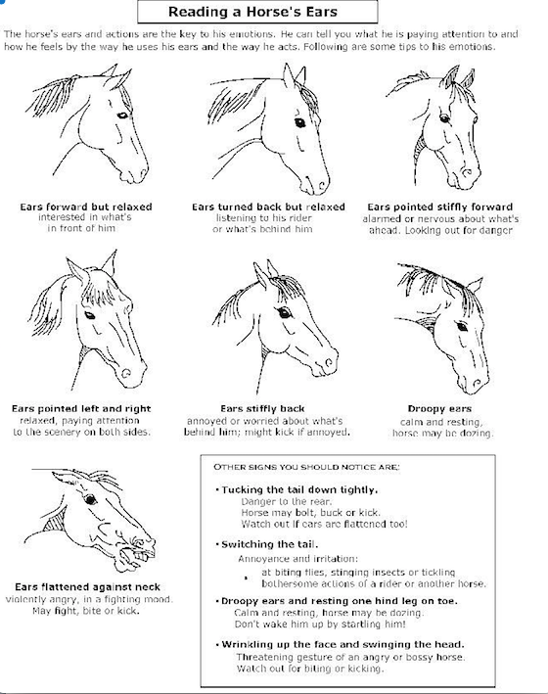
Volunteer Horsemanship 101

Emergency Procedures

The main priority for the Hope Horses, Inc. staff is to do their best to keep any danger from coming to any students, but there is always the possibility that something may happen. During an emergency, there are a few things to remember. Above all else, please stay calm.
- Leaders: Your job is to take care of your horse. In any situation, you are to never let go of your horse. If ever there is an emergency with your student, you are to halt your horse and calm him.
  - In the situation that your rider is still mounted, stop the horse and calm him. Your side walker will notify the instructor of an emergency and will care for your student. The instructor will give you further information once the student is dismounted.
  - If your student has fallen, the side walker will notify the instructor and you are to move the horse out of the way with the horse’s hindquarter’s pointing away for the student.
  - If you do not have a side walker present, stop your horse, verbally notify an instructor, and try to support your student. If the student has already fallen, move your horse away from the student and call on the instructor.
- Side walkers: Your job is to care for the student. In any situation, you are to verbally notify the instructor and take charge for your student. Two possible ways is to do this is by either holding your student on the horse or performing an emergency dismount (you will receive training on this at a later time)
If ever there is an emergency situation with another horse and rider team in the arena or on the trail with you, all other horse and rider teams should stop their horses, remain calm, and wait for further instruction from your instructor.

Leaders – NEVER let go of your horse’s rope for any reason!

Side walkers – NEVER leave your students for any reason!

There is a phone to dial 911 on the filing cabinet in the office and in the volunteer central in the tack room. Emergency information sheets are posted above phones.
Fire extinguishers are located by the feed room door, the groom box shelf, and at the top of the stairs in the hay loft.

Statement of Understanding

I have read, understand and accept the information contained within the Participant Handbook.

Participant’s Printed Name __________________________________________________

Printed Name of Parent or Guardian, if applicable ____________________________

Signature of Participant, Parent or Guardian __________________________________

Date ___________________________________

